NAME: SAYEEM AHMED 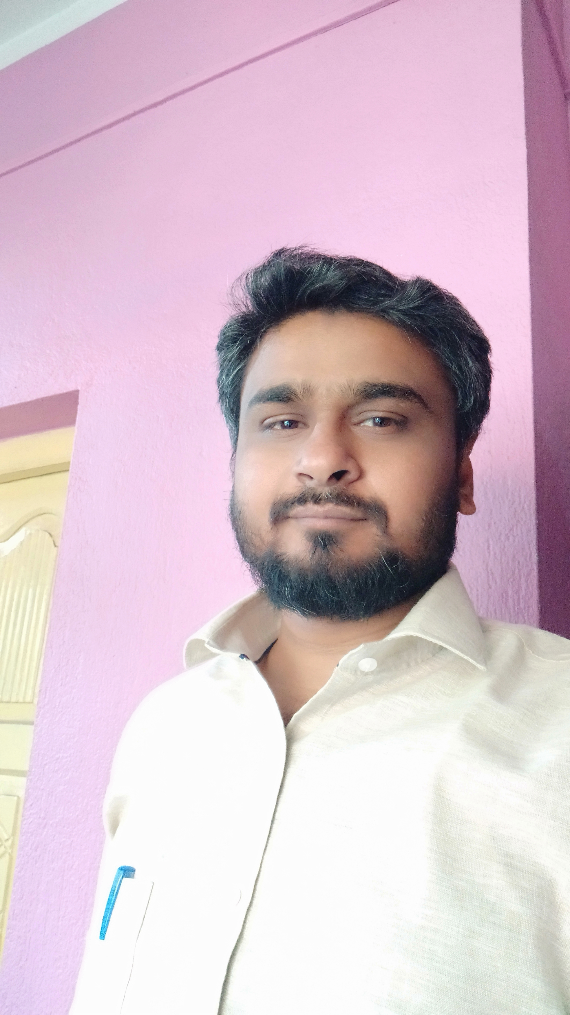
FATHER’S NAME: GIASUDDIN AHMED
MOTHER’S NAME: SANJIDA BEGUM
DATE OF BIRTH: 06/01/1987
PLACE OF BIRTH: MALDA
NATIONALITY: INDIAN
RELIGION: ISLAM
MOTHER TONGUE: BENGALI
LANGUAGES KNOWN: BENGALI, ENGLISH, ARABIC, HINDI & URDU
MOBILE: 8145831667/7908675732
VILLAGE: GOPAL GHOSH TOLA.
P.O.: KRISHNAPUR
P.S.: BAISHNABNAGAR
DIST: MALDA
STATE: WEST BENGAL
PIN: 732210

ADDRESS

GOAL WANT TO LIVE A PEACEFUL LIFE.
EDUCATION QUALIFICATION:
NAME OF THE EXAM | BOARD/UNIVERSITY | SUBJECTS | YEAR OF PASSING
MADHYAMIK | W.B.B.S.E | BEN,ENG,HIST,GEO,PHY,MATH,LSC,WORK & PHYed. | 2002
HS | W.B.C.H.S.E. | BEN,ENG,PHYS,CHEM,BIOS,MATH | 2004
B.A. | UNIVERSITY OF CALCUTTA | ENGLISH HONS | 2007
M.A. | C.S.J.M.U. | ENGLISH | 2009

WORK EXPERIENCE: SERVING AS STATE AIDED COLLEGE TEACHER SINCE NOV 01, 2009 AT KALIACHAK COLLEGE. And currently serving as programme officer NSS, KALIACHAK COLLEGE.

