SOURAV PAUL
Assistant Professor
Department of English
Kaliachak College
Sultanganj
Malda – 732201.
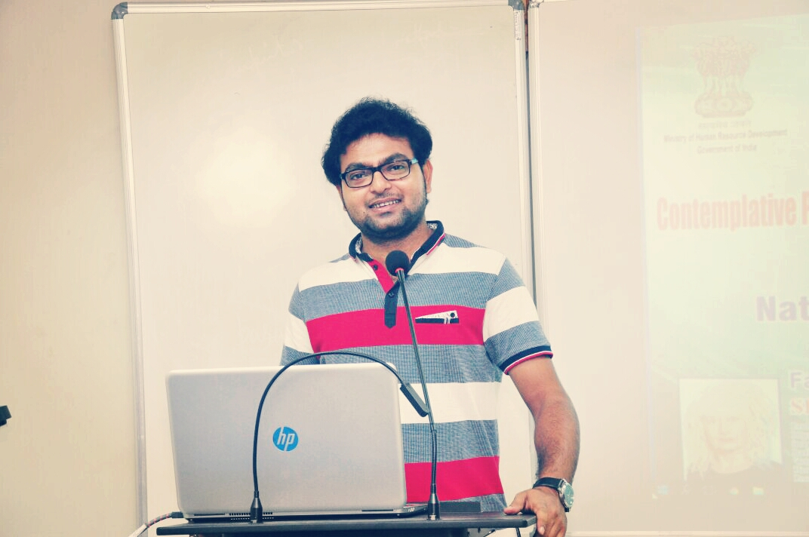
Former UGC Senior Research Fellow
Department of Humanities & Social Sciences
National Institute of Technology Durgapur
West Bengal – 713209

MAILING ADDRESS
Mobile No- +91-9475225797/8918306783
Email- paul.sou.7@gmail.com
Teaching interest
History of English Literature, Literary Theory and Criticism, Metaphysical Poetry, Poetry of Romantic Period, Shakespearean Sonnets, Greek Drama.
Research interest
South Asian Literature, Contemporary Fictions by Muslim Writers, Cinema and Religion.

Academic QUALIFICATION
Degree/Diploma | Board/University | Year of Passing
Madhyamik Pariksha (10) | WBBSE | 2006
Higher Secondary (10+2) | WBCHSE | 2008
B.A (English Hons.) | University of Gour Banga | 2011
M.A (English) | The University of Burdwan | 2013
B.Ed | The University of Burdwan | 2014
SET | West Bengal College Service Commission | 2015
Diploma in Office Automation | JNNYC (approved by Council of Education and Training) | 2016
NET-JRF | UGC | 2016
PhD | NIT Durgapur | Pursuing

Professional training/COURSEs attended
Sl. | Course/Program | Topic | Venue | Duration | Instructor
1. | GIAN (MHRD, Govt. of India) | Cultural Decolonisation in the 21st Century | National Institute of Technology Durgapur | 31 July to 04 August 2017 | Prof Claudio Braga (University of Brasilia, Brazil)
2. | GIAN (MHRD, Govt. of India) | Poetry and Visual Culture | National Institute of Technology Durgapur | 12 October to 16 October 2017 | Prof Obododimma Oha ( University of Ibadan, Nigeria)
3. | GIAN (MHRD, Govt. of India) | Contemplative Photography and General Semantics… | National Institute of Technology Durgapur | 07 November to 11 November 2017 | Prof Shannon Bell (York University, Toronto, Canada)
4. | User Awareness Program | E-Books and E-Journals | Central Library, NIT Durgapur & Elsevier | 17 January 2018 | Prof Apurba Dey & others
5. | National Workshop (TEQIP, Govt. of India) | Introduction to the Digital Humanities | Indian Institute of Technology Guwahati | 27 to 28 May 2019 | Prof Samantak Das (Jadavpur University) & others

Faculty induction/orientation program etc attended
- 4 Week Induction/Orientation Programme for Faculty in Universities/ Colleges/ Institutes of Higher Education organized by Teaching Learning Centre, Ramanujan College, University of Delhi under the aegis of Ministry of Education, Pandit Madan Mohan Malaviya National Mission on Teachers and Teaching, Govt of India, 2021.

Academic Program Organised
Convened an international webinar entitled "Rabindra-Nazrul: Today" under the aegis of Kaliachak College, UGB on 23.06.2021

Publication (Research paper)
- “Reconfiguration of Indian politics in Girish Karnad’s The Fire and the Rain and other plays”, The Literary Herald: An International Refereed English e-Journal. Volume 2, Issue 2, September 2016 issue, ISSN: 2454-3365.

- “ ‘In-between’ the Ruptures of Violence and Emotion – Anewed Imagination of Women and ‘Alternative Sexuality’ in Neel Mukherjee’s A Life Apart and The Lives of Others”, LangLit: An International Peer-Reviewed Open Access Journal. Volume 3, Issue 2, November 2016 issue, ISSN: 2349-5189.

- “Sexual Violence and Sainthood: A Critical Study of Our Lady of Alice Bhatti”, Rupkatha Journal on Interdisciplinary Studies in Humanities. Volume 10, Number 3, October 2018, ISSN: 0975-2935.

- Willow Trees Don’t Weep by Fadia Faqir (book review), Asian Journal of Women’s Studies (Routledge), Vol 26 Issue 1, 2020, ISSN: 1225-9276, 2377-004X (web)

- “Modeling multidimensional poverty and vulnerability of snake charmers: a crossstate comparative analysis of Bihar and Odisha, India”, Modelling Earth Systems & Environment (Springer), Vol 6 Issue 4, 2020, ISSN: 2363-6211 (Electronic)

- “LONG-TERM VISION OF DEVELOPMENT IN POST COVID-19 ERA: A NORMATIVE THEOREM IN WORLD PERSPECTIVE”, Ensemble (UGC CARE enlisted journal) special issue 1, 2021, eISSN: 2582-0427

Publication (poetry)
- “CYBORGS”, Research Scholar: An International Refereed e-Journal of Literary Explorations. Volume 4, Issue IV, November 2016, ISSN: 2320-6101.
- “Lines Written on a Valentine Night”, The Criterion: An International Journal In English. Volume 8, Issue 1, February 2017 issue, ISSN: 0976-8165.
- “When a Jilted Heart Revolves to Rise”, Learning & Creativity, December 2017. http://learningandcreativity.com/jilted-heart-revolves-rise/ ; also published in revision as “Darkness Rising”, Indifaring Muse (An Anthology of Poems). Volume 2. August 2018.
- “Ode to the Moon”, Indifaring Muse (An Anthology of Poems). Volume 2. August 2018.

Papers presented in Seminar/conference

Sl. | Conference/Seminar | Topic | Venue | Sponsoring Agency | Date
1. | International Seminar on ‘Women in Texts’ | Sexual Violence and Sainthood: A Critical Study of Our Lady of Alice Bhatti | Jhargram Raj College, West Bengal | Government of West Bengal | 15-16 March 2018
2. | International Conference on ‘Moving Beyond the Margin: The Politics of Exclusion and Assimilation’ | (B)ordering Woman Body – A Reading of Fadia Faqir’s Willow Trees Don’t Weep | Central University of Rajasthan | Department of English, School of Humanities & Languages, CUR | 15-16 November 2018
3. | International Conference on ‘South Asian Literature, Culture & Society’ | The New Xenophobia: A Post 9/11 Reading of Fadia Faqir’s Willow Trees Don’t Weep and Ayesha Tariq’s Sarah | B.B.T.M College, Purulia, West Bengal | IQAC, B.B.T.M College | 27-28 February 2019

Seminar/webinar participated

Sl. |  | Seminar/Webinar | Topic | Organizing Institute/Agency | Date
1. |  | Periodic Lecture & National Seminar | Philosophy and Nation Building | Department of Philosophy, Kaliachak College, Malda, West Bengal | 7th March 2020
2. |  | Three Day International Webinar | Postcolonial Negotiations: History, Literature & Culture | Department of English, BBTM College & Sidho Kanho Birsha University, Purulia, West Bengal | 3-5 June 2020
3. |  | International Webinar | COVID-19: A Paradigm Shift in Teaching-Learning, Problems & Prospects | IQAC, Kaliachak College, Malda, West Bengal | 10th June 2020
 | 4. | International Webinar | Atmanirbhar Bharat Abhiyan and Indian Economy under COVID-19: Road Ahead | SG Govt Degree & PG College, Andhra Pradesh | 10th June 2020
 | 5. | National Webinar | Role of Science & Technology During COVID-19 Pandemic | Dayanand College, Hisar, Haryana | 12th June 2020
 | 6. | National Webinar | Role of ICT in the Process of Teaching & Learning in the Digital Era | Department of English, BGSB University, Jammu & Kashmir | 15th June 2020
 | 7. | International Webinar | Contemporary Literary Theories | Department of English, BGSB University, Jammu & Kashmir | 16th June 2020
 | 8. | International e-Seminar | Cyber Crimes & Impact of COVID-19 on Higher Education | IQAC, Janata Mahavidyalaya, Maharashtra | 17th June 2020
 | 9. | National Webinar | ‘The still, sad music of humanity’; COVID-19 Crisis and Coping Strategies | Department of English, Malda Women’s College, West Bengal | 18th June 2020
 | 10. | National Webinar | Paradigm Shift to Education System: Impact of Basic & Applied Research | Central Library Readers’ Forum, Manipal University, Jaipur, Rajasthan | 19th June 2020
 | 11. | National Webinar | Mind, Body, Exercise & Lifestyle Management in Changing Environment | Department of Yoga & NSS, Midnapore College (Autonomous), West Bengal | 21st June 2020
 | 12. | One Day International Webinar | Pandemic & Societal Implications: India & Her Neighbours | Women Cell, Kulti College, West Bengal | 22nd June 2020
 | 13. | Three Day International Web Lecture Series | An International Web Lecture Series | IQAC & Department of English, BBTM College, Purulia, West Bengal | 23-25 June 2020
 | 14. | National Webinar | Transforming Higher Education in the Context of COVID-19 | Jointly Department of Education, AMMT College & Plassey College, Nadia, West Bengal | 24th June 2020
 | 15. | Two Day International Webinar | Post COVID-19 Environmentalism: Possible Futures | Dept of English & Political Science (IQAC), Dr B.R.Ambedkar College, Nadia, West Bengal | 24-25 June 2020
 | 16. | Two Day National Webinar | Life Writing: Historical Contexts & Literary Perspectives | Derozio Memorial College, Kolkata, West Bengal | 27-28 June 2020
 | 17. | Three Day National Webinar | Social Implications of COVID-19 | Department of Sociology, Bangalore University, Karnataka | 27th, 29th & 30th June 2020
 | 18. | One Day Webinar | Impact of COVID-19 on Gender Equality | Jointly Sikkim University & University Grants Commission (UGC) | 30th June 2020
 | 19. | Web Lecture | Help your students improve their writing skills with Write & Improve | Cambridge University, United Kingdom | 1st July 2020
 | 20. | State Level Webinar | 100 Years of Jalianwalabagh Massacre | Department of History, BKC College, Kolkata, West Bengal | 7th July 2020
 | 21. | Two Day National Webinar | Re-Reading and Re-Contextualising Literary Text in Times of Pandemic | Department of English & IQAC, Amdanga Jugal Kishore Mahavidyalaya, West Bengal | 13-14 July 2020
 | 22. | State Level Webinar | Glimpses of Bengal Rural Society: The Colonial Experiences | Department of History & IQAC, PCM Mahavidyalaya, West Bengal | 14th July 2020
 | 23. | One Day National Webinar | Deconstruction & Its Application on Text | Department of English, Govt Degree College Thothri, Jammu & Kashmir | 17th July 2020
 | 24. | International Webinar | Work Culture in Changing Time | Jointly Department of Commerce, Mahatma Gandhi Central University, India & University of Guadalajara, Mexico | 4th August 2020
 | 25. | International Webinar | Kashmir and Kashmiriyat: A Historical Perspective | IQAC, Amar Singh College, Srinagar, J&K | 27th August 2020
 | 26. | International Web Lecture Series | Postcolonial Theory and Praxis | Jointly Departments of English Onda Thana Mahavidyalaya & TDB College, West Bengal | 12-14 October 2020
 | 27. | International Webinar | Netaji Subhash Chandra Bose: A National Hero | Kaliachak College, Malda, West Bengal | 23rd January 2021
 | 28. | National Seminar on International Women’s Day | Are Women Better Leaders | Department of English, BGSB University, Rajouri, Jammu & Kashmir | 8th March 2021
 | 29. | Three Day Webinar | Role of Teachers in Institution Building | IQAC, Deshabandhu Mahavidyalaya, Chittaranjan, West Bengal | 5-7 May 2021
 | 30. | One Day National Webinar | Adolescence: The Paradigm Shift in Human Life | NMM College, South Dinajpur, West Bengal | 19th May 2021
 | 31. | Three Day International webinar | South Asian Literature: Emerging Trends & Global Perspectives | Jointly Department of English & Centre for Endangered Languages, SKB University, India & Green University, Dhaka, Bangladesh | 3-5 June 2021

Academic awards/achievements:
- UGC Junior Research Fellowship, 2017
- UGC Senior Research Fellowship, 2019
- Editorial Board Member, Humanities and Social Science Research Journal, Ideas Spread Inc, New York, USA, 2020
- Editorial Board Member, International Linguistic Research Journal, Ideas Spread Inc, New York, USA, 2020
- Honorary Rosalind Member of London Journals Press (Quarterly), Theale, UK, 2020

