Personal Profile
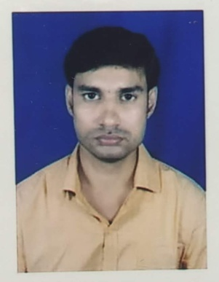
1.Name : Md Samim Akhtar
Designation : State Aided College Teacher
Department : Botany
Affiliation : Kaliachak College Sultanganj, Malda
S/o :Md Sohorab Ali
Date of Joining : 29.01.2013
Experience : 8 years 5 month
2.Personal Contact :
Residense: Manmatho Sarkar Road, P.O – Dhuliyan, District – Murshidaabad, Pin – 742202
Mobile : 7384155968 / 7908194884
Mail Id : samimrok123@gmail.com
3.Academic Qualification :
Sl No | Exam Passed | Board/ University | Institution | Year
1 | M. P | WBBSE | Kanchantala J.D.J Institution | 2001
2 | H. S | WBCHSE | Kanchantala J.D.J Institution | 2003
3 | B. Sc( Botany) | C. U | Surendranath College | 2006
4 | M. Sc ( Botany) | G. G. U | D.L.S P.G College | 2009
5 | B. Ed | G. B. U | GourMalda College of Education | 2017

4. Specialization : Plant Pathology
5. Working Experience :
i. Joined as a guest Lecturer in Kaliachak College on 29th Jan 2013.
ii. Became State Aided College Teacher in Kaliachak College from 1st jan 2020.
6. Short-Term Course Attended :
SL. | Theme | Venue | Organizer | Sponsored | Period
1. | Gender Equality | Conference Hall, Kaliachak College | Kaliachak College In Collabration with HRDC (UGC), AMU | Pandit Madan Mohan Malaviya National Mission for Teachers and Teaching, MHRD, Gove of India | 26th May to 1st July 2016
2 | Implementation of Under Graduate Syllabus | Department of Botany,UGB | Department of Botany,UGB | University of Gour Banga | 13th Nov to 19th Nov 2017

7. Perticipated in Seminars / Webinars
i) NAAC sponsored National Workshop on the Quest for quality in HEIs organised by Kaliachak College on 26th Feb to 27th Feb 2018.
ii) NCW sponsored Workshop in the Nation Wide competition on Laws Related to Women on 24th Dec 2018.
ii) National Seminar on Philosophy and Nation Building Organized by ICPR, MHRD, Government of India, and Department of Philosophy,Kaliachak College on 7th March 2020.
IiI) INTERNATIONAL WEB-WORKSHOP on COVID-19: A Paradigm Shift in Teaching-Learning,Problems & Prospects on 10th June 2020.
iv) International Webinar on Pedagogical Inventions in Research Scenario in COVID-19 Period and Beyond on 22nd June 2020.
v) Webinar on Thinking, Remembering World Poet Rabindranath Tagore, Conducted by Cultural Department of Kaliachak College on 7th Aug 2020.

