Dr. KASHINATH NANDI. 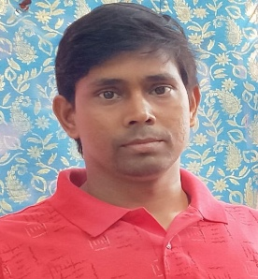
Assistant Professor of Sanskrit,
Kaliachak College,
Sultanganj,
Malda – 732201.

Date of joining- 14/11/2019.
Contact no- 9433720624.
DOB- 02/01/1982
Email Id- kashidumdum@gmail.com

Address -
Village- Raghumandal Sayer, P.O- Deshra, P.S- Kotulpur, dist.- Bankura, Pin- 722141.

Present Address -
Andul Chowdhury para, P.O- Andul- Mouri, P.S- Sankrail, Dist.- Howrah, Pin- 711302.

Educational qualification -
M.A. (Acharya) in Sanskrit from Rashtriya Sansktita Sansthana.
M. Phil from Rabindra Bharati University.
Ph.D. from Rabindra Bharati University.

Work experience –
13 years (as a gov. Approved part- Time Teacher, 20/7/2007to13/11/2019) 8 years as a HOD in Rabindra Mahavidyalaya.
Assistant professor from 14/11/2019 in Kaliachak College,

Publication (Research paper)
- Journal of the department of Sanskrit, Rabindra Bharati University, vol.-xx 2014-2015. Kolkata.
- Sansktita Sahitya parisad patrika,vol. Lxxxxvii Nos 1-4, 2015, Kolkata.

Papers presented (Seminar/Conference)
- All India Oriental Conference, 46th session, University of Kashmir.
- Department of Sanskrit in collaboration with IQAC, Panchmura Mahavidyalaya, Bankura, West Bengal.

Induction/ Orientation program:
- Teaching Learning Center, Ramanujan College, University of Delhi.

