BIO-DAT NAME : ANUWARUL ISLAM 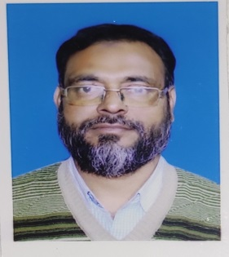
DESIGNATION : STATE AIDED COLLEGE TEACHER (SACT )
DEPARTMENT : ARABIC
COLLEGE : KALIACHAK COLLEGE, KALIACHAK, MALDA
DATE OF JOINING : 01/11/2009
ADDRESS
FATHER NAME : EJABUL HOQUE
VILL : CHANDPUR MADANIPARA
POST OFFICE : DHANGARA
POLICE STATION : CHANCHAL , DISTRICT : MALDA
STATE : WEST BENGAL , PIN – 732125
NATIONALITY : INDIAN
RELIGION : ISLAM
DATE OF BIRTH : 25/12/1978
CONTAACT NO – 9734181525/8617626997 , EMAIL ID – anuwarulcmpara@gmail.com
Qualifications
NAME OF EXAM | BOARD/UNIVERSITY | YEAR OF PASSING | SUBJECT
MADHYAMIK/ALIM | WBBME | 1995 | Ben,Eng,Arab,Math,P.sc,L.sc,His,Geog,Fiqh,Taf, Hadith,Farayez
H.S/ENTERMEDIATE | BEMEC | 2002 | Ben,Eng,Hindi,Arabic,History,Geog,Sociology
B.A (HONS) ARABIC | PATNA UNIVERSITY | 2006 | Arabic ( Hons ) , History , Sociology , General Studies
M.A IN ARABIC | PATNA UNIVERSITY | 2008 | Arabic
Extra Qualification
M.M (Mumtazul Mohaddethin) | WBBME |  | Bukhari-I,II,Muslim,Nasayee,Tirmidhi,Abu Daud,Ibn Majah,Tafsir Baidawi,Tafsir Kashshaf,Tarikh-ul-Islam

