Biodata

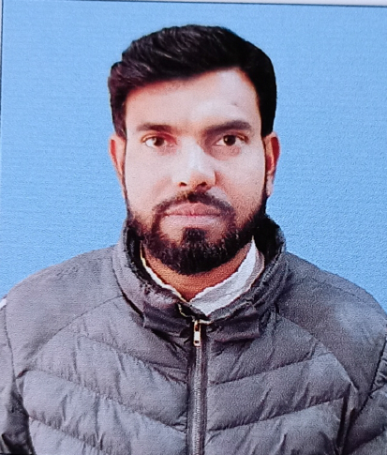
Name : ABDUR RAUF SHAMIM
Designation : State Aided College Teacher
Date of Birth : 1st January, 1987
Citizenship : INDIAN
Gender : MALE
Official Address : Dept. of Urdu, Kaliachak College, Sultanganj, Malda 732201
Permanent Address : Vill: Ramnagar, P.O: Jampur, P. S: Barharwa, Dist:Sahibganj, Jharkhand
Pin: 816101

E-mail : abdurraufshamim@gmail.com

Mobile No : 9162765279
Academic Qualifications : M.A , B.Ed

